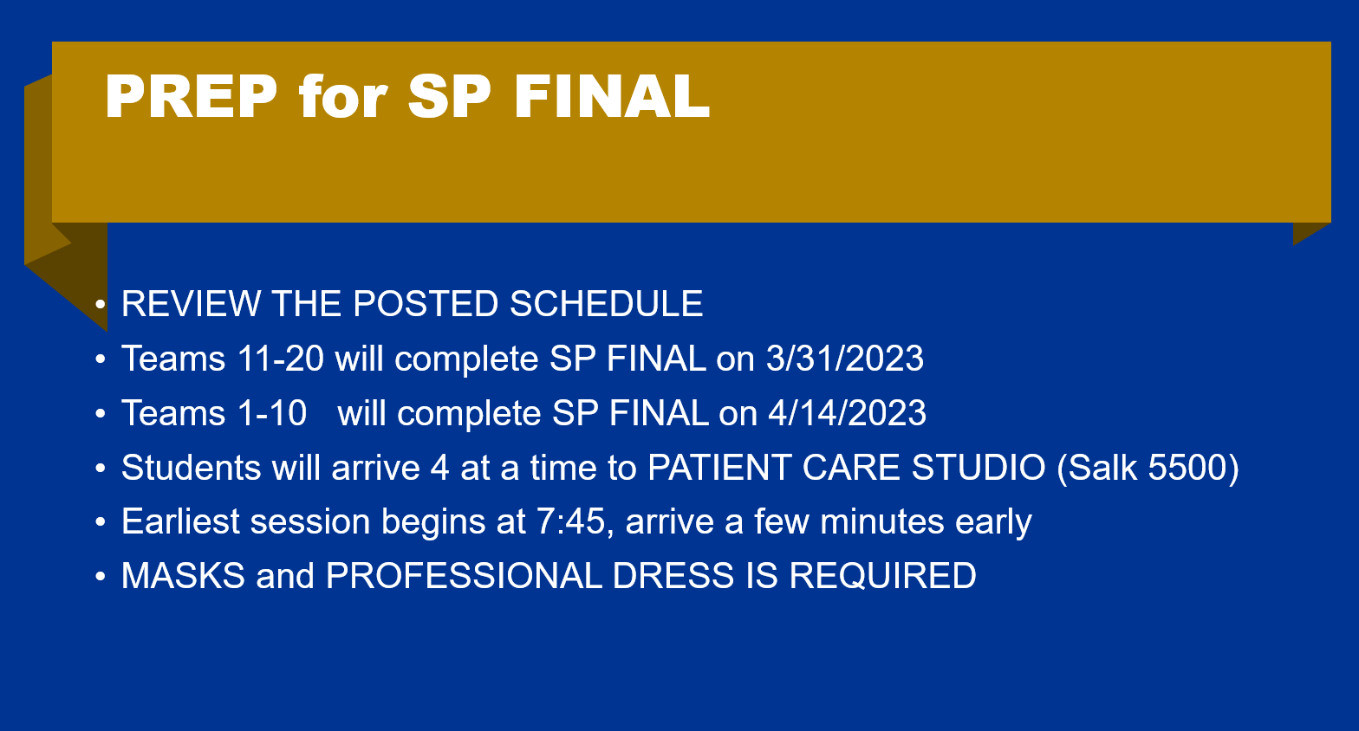

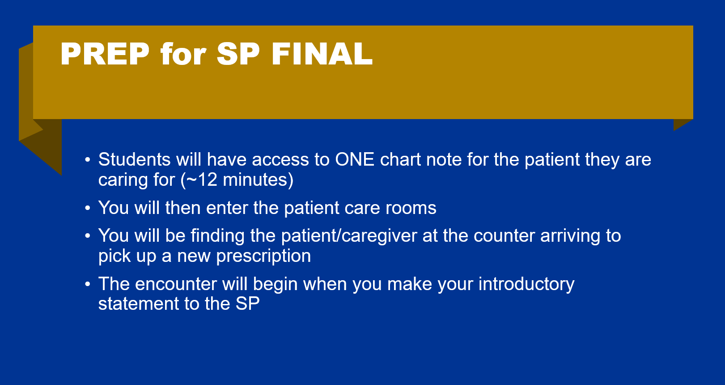

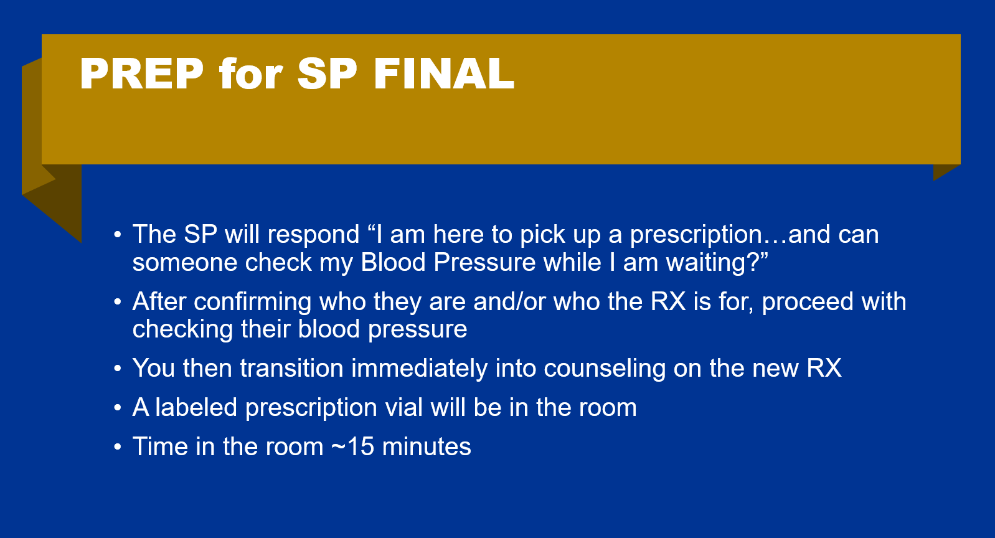

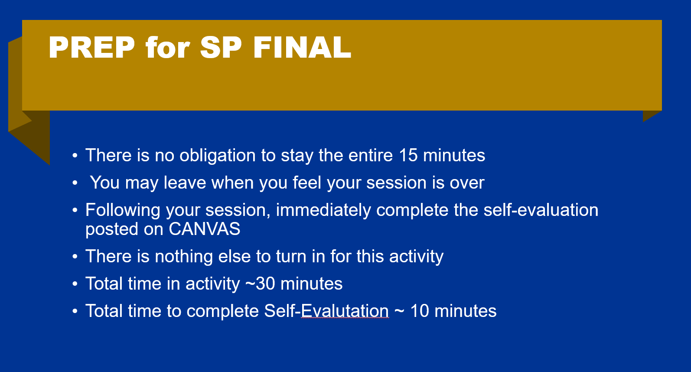

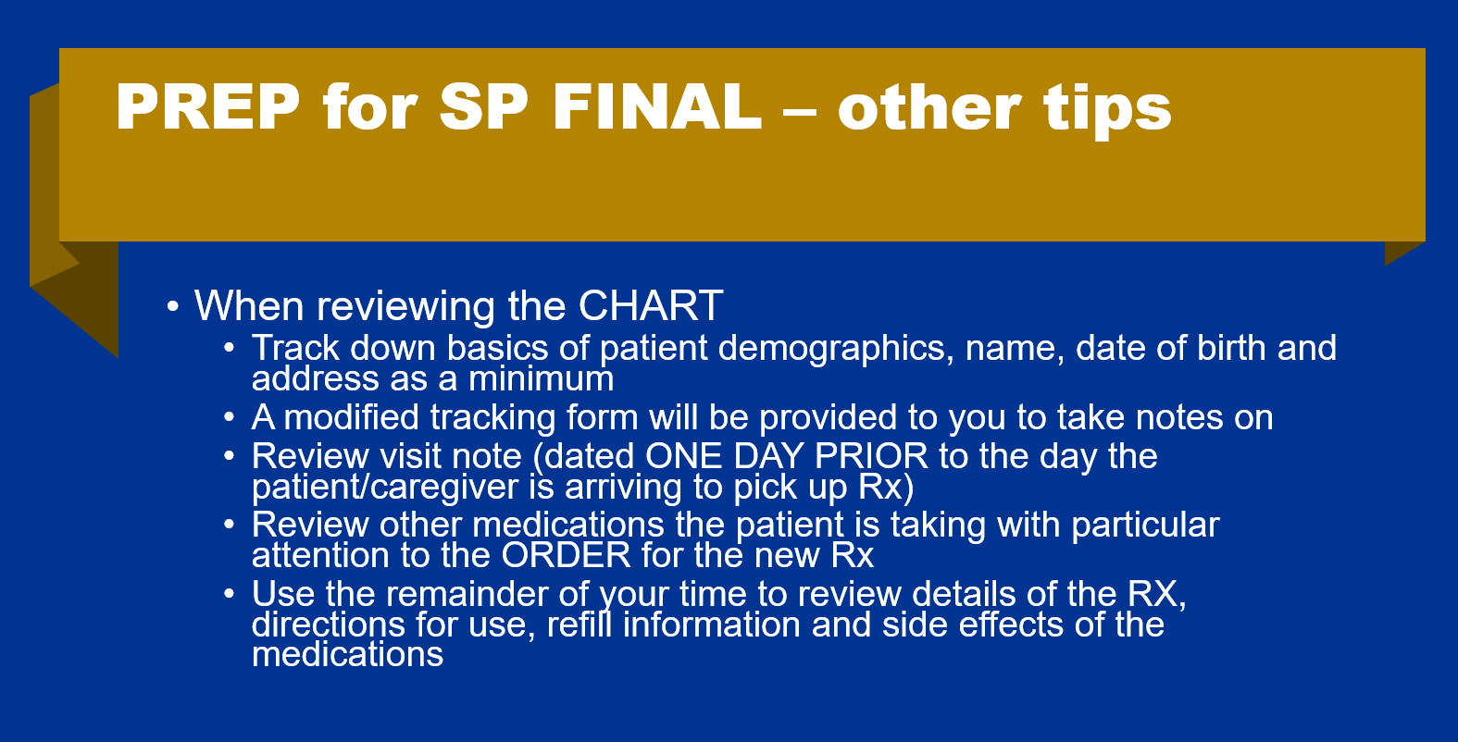

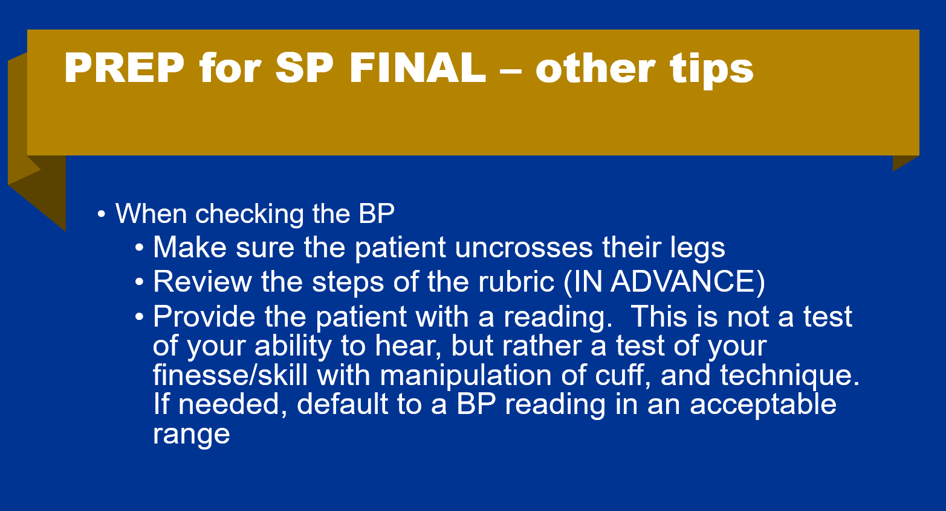

FEEDBACK FROM SP’s and FACILITATORS – WHAT WENT WELL?

* Great introductions (first and last name, and role at the pharmacy)
* Showed care and empathy for patient
* Very open to the experience
* Eager to learn and get feedback on how to improve
* Great self-awareness of what went well and how to improve
* Good flow to patient counseling
* Good non-verbal communication from students including leaning in, eye contact, shaking their head
* Some asked the SPs pronoun preferences
* Rapport building
* Appropriate use of Rx vial for “show and tell”
* Called “time out” appropriately when needed
* Asked peers for assistance when needed
* Provided feedback to peers during “time out”

FEEDBACK FROM SP’s and FACILITATORS – WHAT CAN BE IMPROVED?

(The following feedback relates directly to the rubric)

INTERVIEW TECHNIQUE 28 POINTS

* Clarify who the prescription is for EARLY in the conversation
* Explaining the purpose of the counseling session
  + Having a short statement to explain the counseling session that you can recall each and every time you are counseling a patient is helpful.
  + Example: *Today we are going to spend a few minutes to review your new medication and how it compares to your other medications on your profile, to make sure you have the best understanding of how it works and what to expect in regard to both safety and efficacy.*
* Being prepared to quickly use info from patient profile
  + Brief demographics
  + Current meds (this should include OTC medications)
  + Allergies
* Show and Tell method (visibly showing the medication to the patient by taking the lid of the vial and letting them see what it looks like. Example: “*This is your amlodipine, it is a 25mg dose and it comes as a white tablet”.*
* Asking closed ended questions for the 3 prime questions
  + EXAMPLE:
  + WHAT did the doctor tell you this was for? “*it’s for my blood pressure”_*
  + VERSUS
  + DID the doctor tell you what this was for? “*They sure did….”*
* Wrapping up the session, offering recap and teach back method
  + EXAMPLE: “*just to make sure I didn’t leave anything out, can you tell me what this medication is for and how you are going to take it?”*

KNOWLEDGE BASE 6 points

* Over reliance on notes once counseling began
* Concerned over “accuracy” that might have left patient questioning confidence/competence
* Storage recommendations – in the bathroom (not ideal)
* Brand name vs generic name, and being prepared to use both names if needed

OVERALL COMMUNICATION 36 points

* Language
  + Medical terminology vs Patient friendly language
  + Avoid temptation to curse if something is not going right
  + Awareness of filler words
    - EXAMPLE: “um, gotcha, all righty, okay….”
* Lack of open ended questions
* Presentation of information in logical fashion
* Being overly concerned about hitting points on the rubric without addressing patient concerns
* Realizing missed/skipped information but never doubling back because they weren’t sure if they could
* Being comfortable saying “I don’t know, but I will get back to you”